Islamic lighting

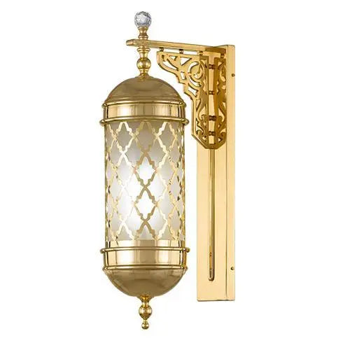

**Islamic - 1 Bulb - Gold - Glass Msnfr**

Brand : AsfourProduct Type : Wall LampProduct Family : IslamicColor : GoldMaterial : BrassDecoration Materials : Glass...

Vendor: [Asfour Crystal](https://shop.asfourcrystal.com/collections/vendors?q=Asfour%20Crystal)

SKU: 34114/121/119/163

Availability: In Stock

Product Type: Wall Lamps

Brand :: Asfour Asfour

Top of Form

Bottom of Form

Top of Form

Subtotal: EGP 8,490.00

Bottom of Form

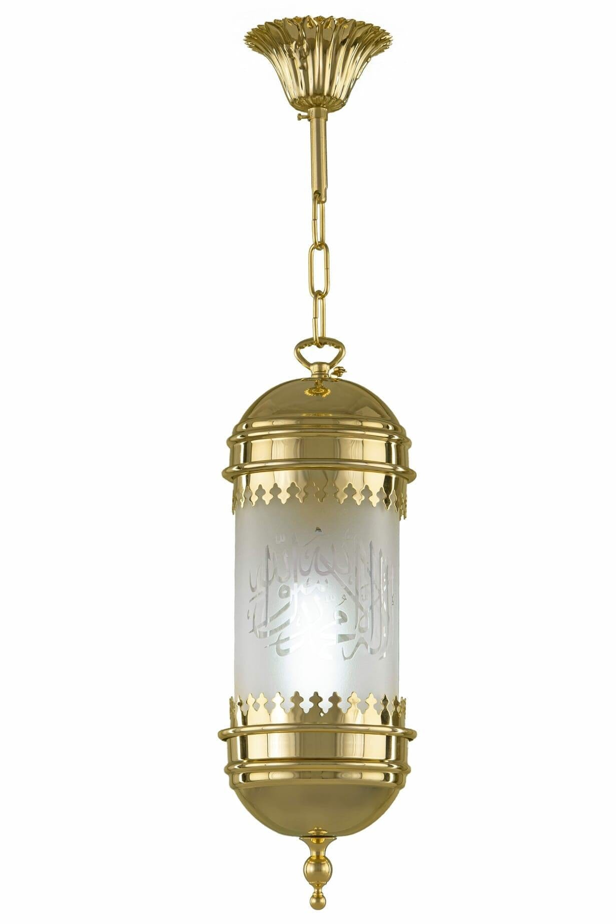

**Pendant S.zaib Gold Without Crystal - 1 Bulb**

Brand : AsfourProduct Type : PendantProduct Family : IslamicColor : GoldMaterial : BrassDecoration Materials : Without CrystalNumber...

Vendor: [Asfour Crystal](https://shop.asfourcrystal.com/collections/vendors?q=Asfour%20Crystal)

SKU: 34115/128/119/100

Availability: In Stock

Product Type: Pendants

Brand :: Asfour

Top of Form

Bottom of Form

Top of Form

Subtotal: EGP 4,000.00

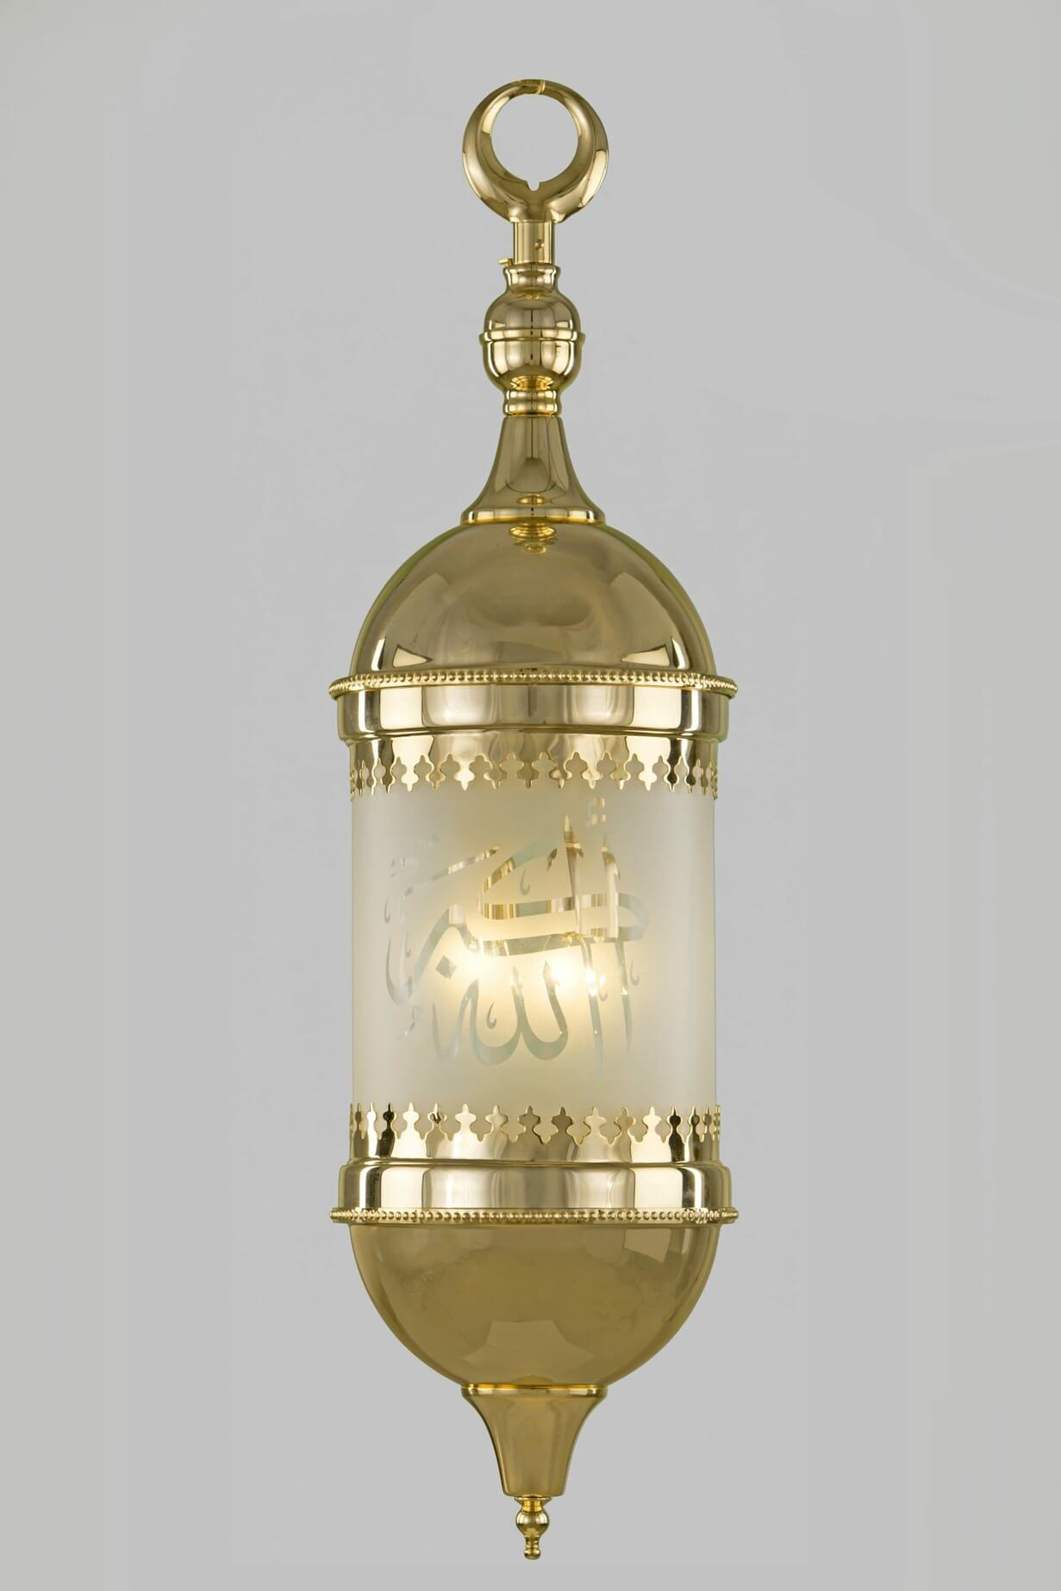

**Pendant S.zaib Gold Without Crystal - 4 Bulb**

Brand : AsfourProduct Type : PlafonnierProduct Family : IslamicColor : GoldMaterial : BrassDecoration Materials : Without CrystalNumber...

Vendor: [Asfour Crystal](https://shop.asfourcrystal.com/collections/vendors?q=Asfour%20Crystal)

SKU: 34115/129/119/100

Availability: In Stock

Product Type: Pendants

Brand :: Asfour

Top of Form

Bottom of Form

Top of Form

Subtotal: EGP 12,800.00

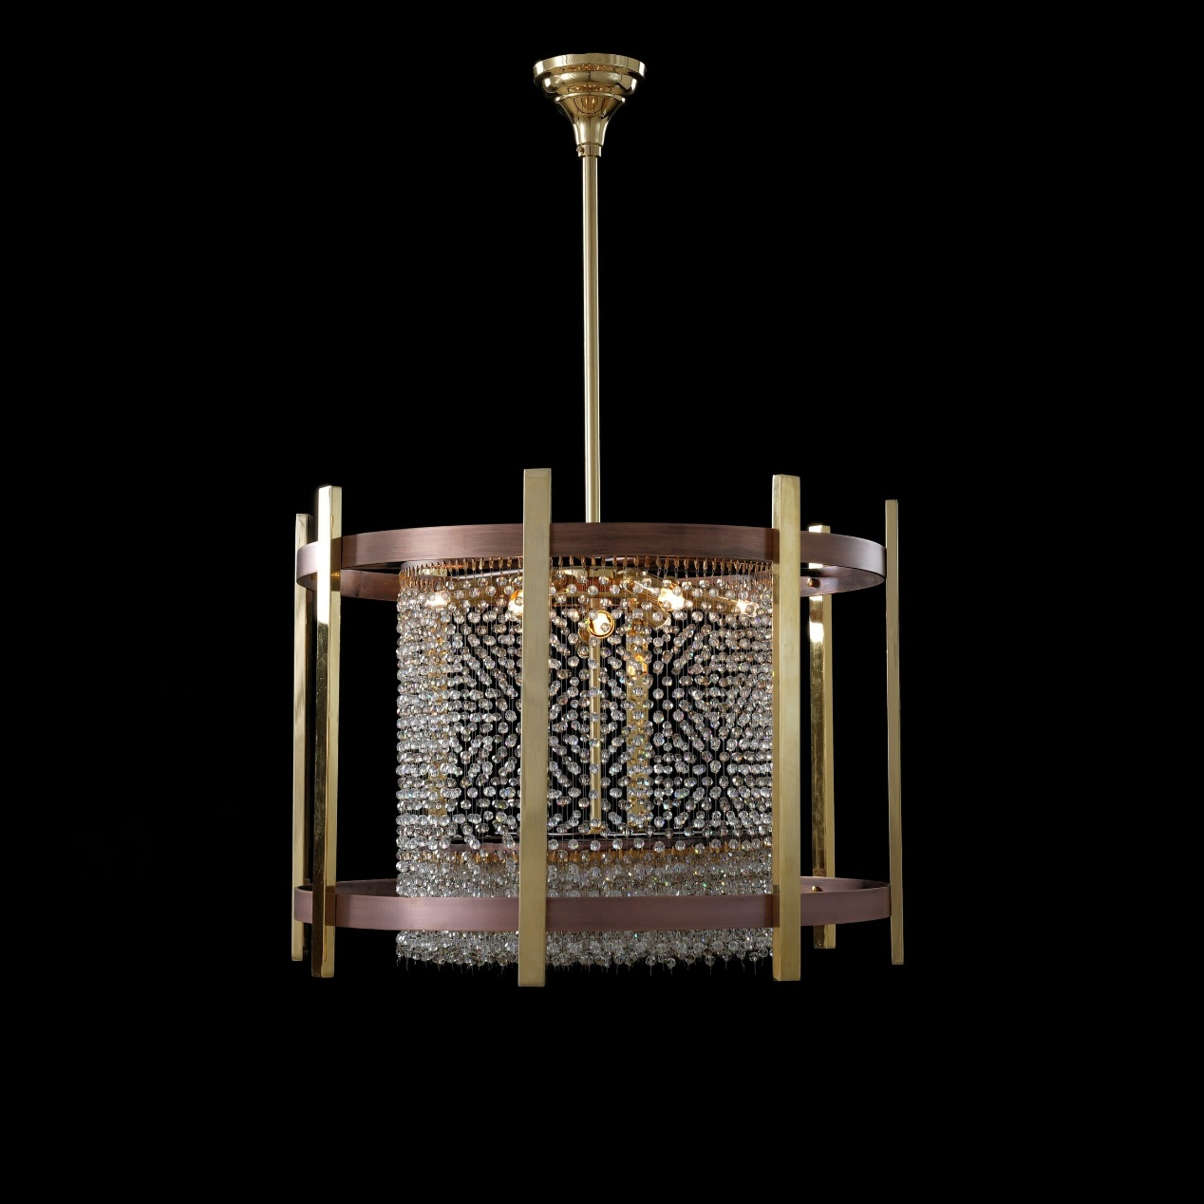

**Asfour Chandelier Gold Old Brown Bearish Honey Clear**

Asfour Chandelier 16/196/50 Gold?Old Brown Bearish Honey Clear About This Product Brand : AsfourProduct Type : ChandelierProduct...

Vendor: [Asfour Crystal](https://shop.asfourcrystal.com/collections/vendors?q=Asfour%20Crystal)

SKU: 33111/759/146/193

Availability: In Stock

Product Type: Chandeliers

Brand :: Asfour

Top of Form

Bottom of Form

Top of Form

Subtotal: EGP 20,530.00

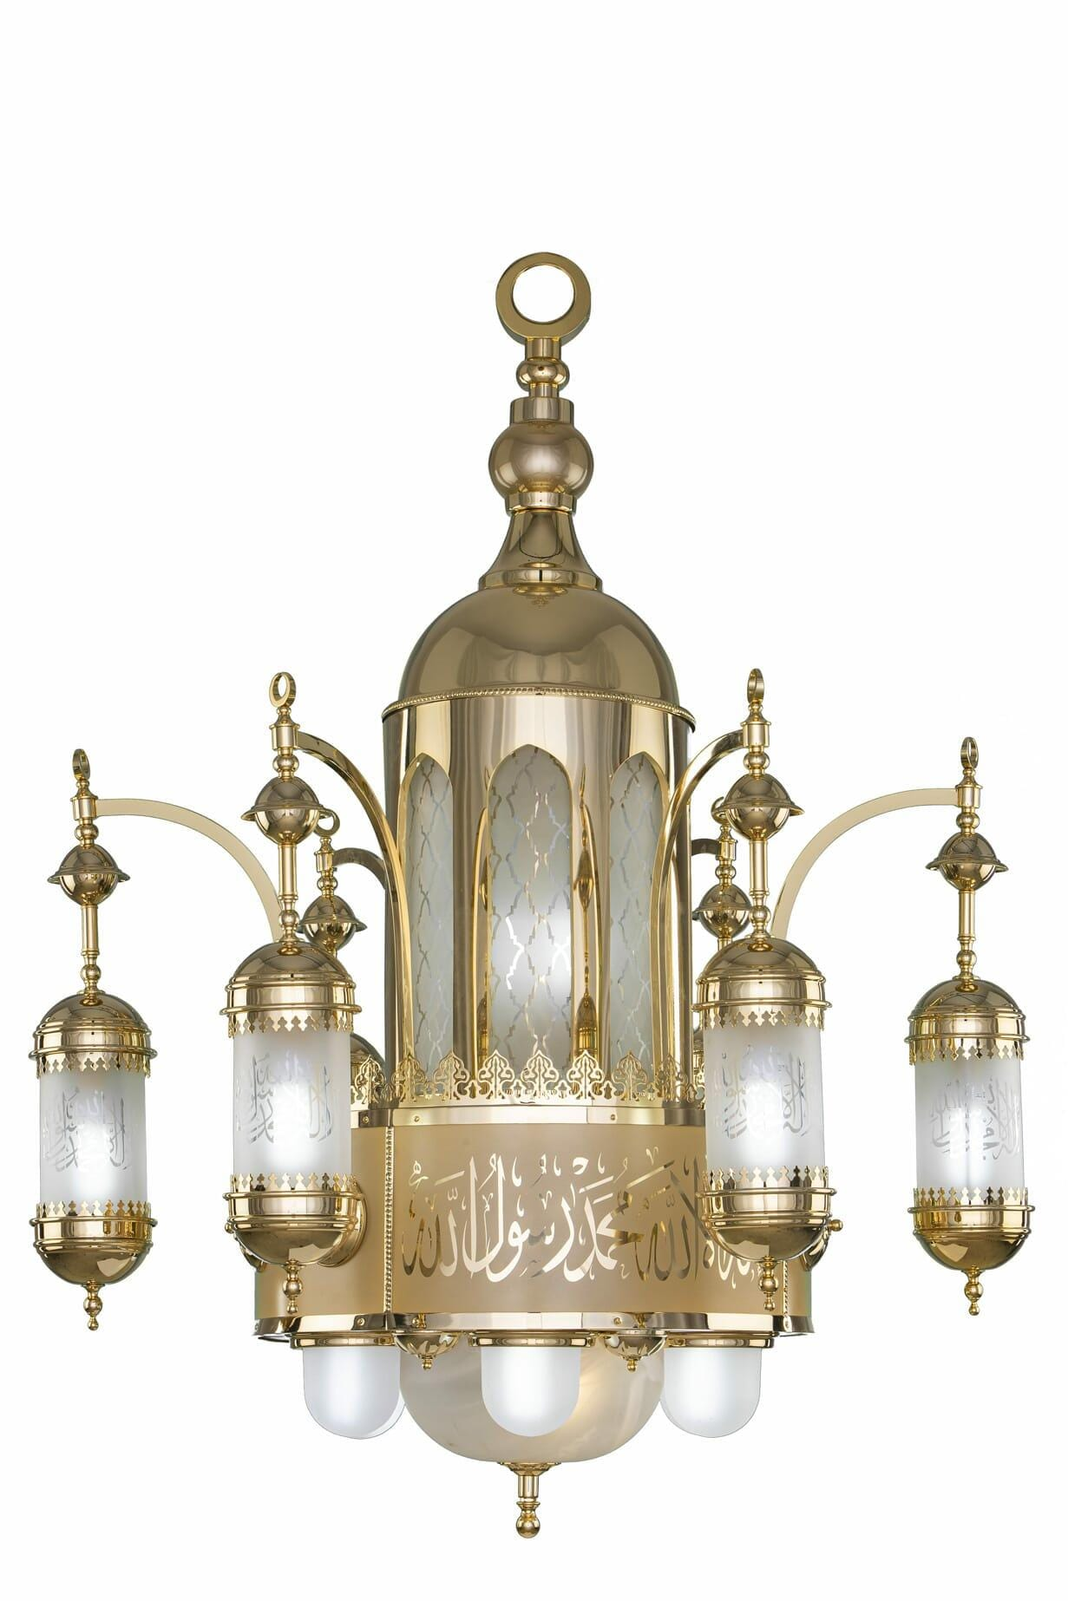

**Chandelier S.zaib 120cm Gold Without Crystal 16 Bulb**

Chandelier S.zaib 120cm Gold Without Crystal 16 Bulb About This Product Brand : AsfourProduct Type : ChandelierProduct...

Vendor: [Asfour Crystal](https://shop.asfourcrystal.com/collections/vendors?q=Asfour%20Crystal)

SKU: 34111/113/119/100

Availability: In Stock

Product Type: Chandeliers

Brand :: Asfour

Top of Form

Bottom of Form

Top of Form

Subtotal: EGP 120,010.00

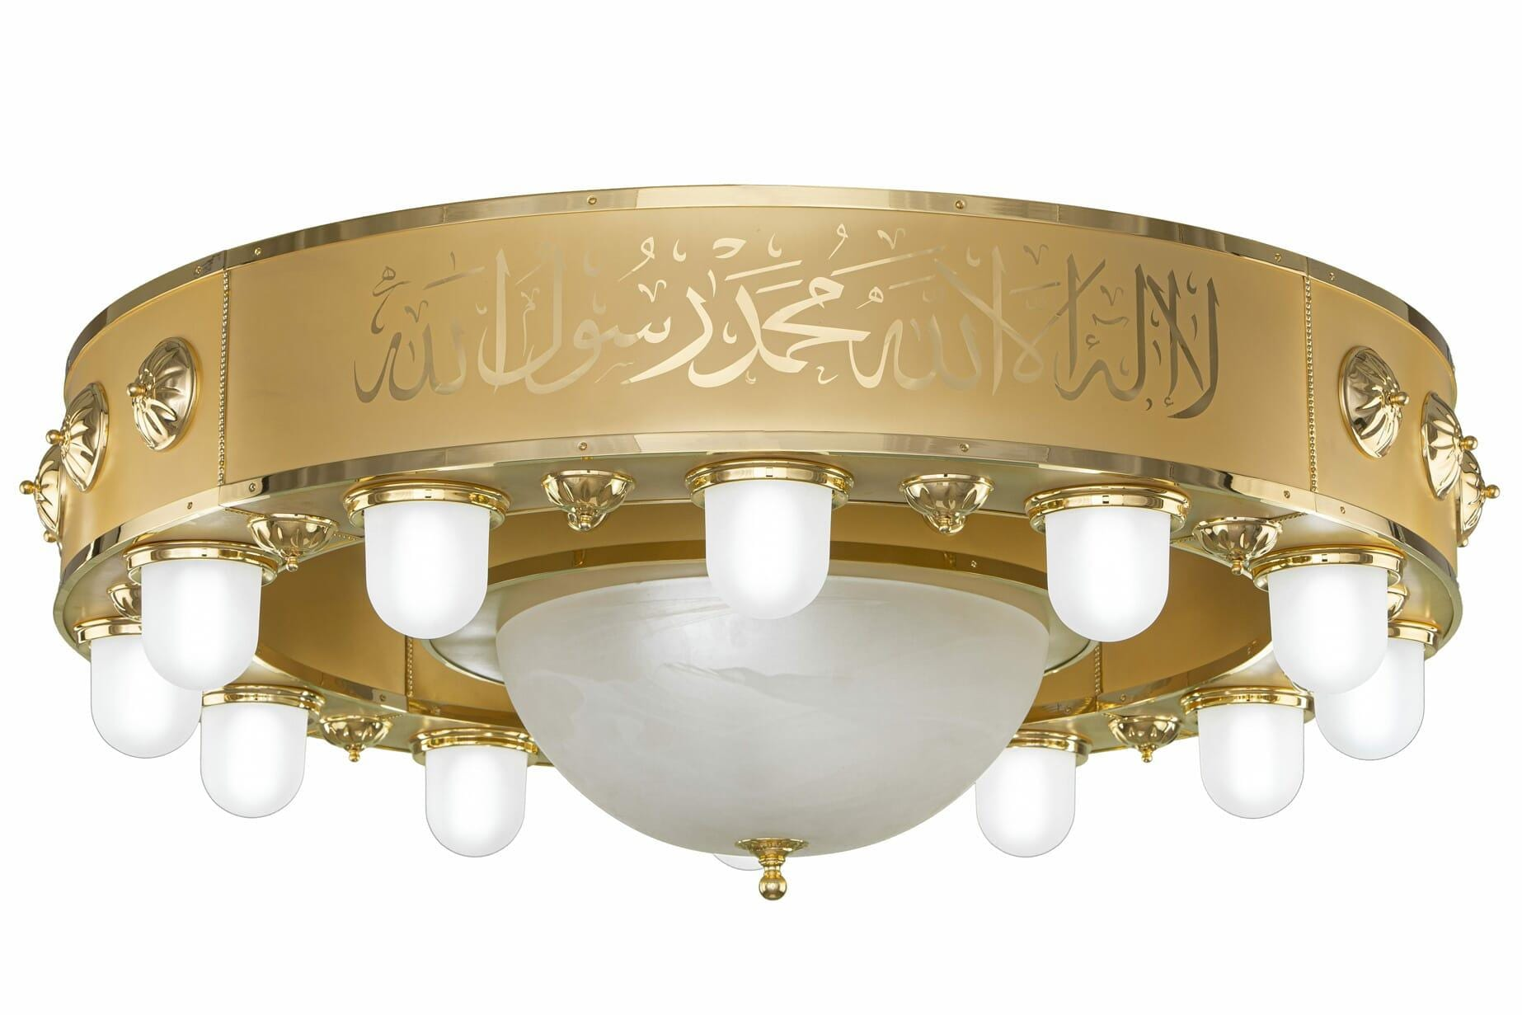

**Ceiling Lamp S.Zainb Gold Without Crystal - 14 Bulb**

Ceiling Lamp S.Zainb Gold Without Crystal - 14 Bulb About This Product Brand : AsfourProduct Type :...

Vendor: [Asfour Crystal](https://shop.asfourcrystal.com/collections/vendors?q=Asfour%20Crystal)

SKU: 34113/120/119/100

Availability: In Stock

Product Type: Ceiling Lamps

Brand :: Asfour

Top of Form

Bottom of Form

Top of Form

Subtotal: EGP 120,010.00

# https://shop.asfourcrystal.com/cdn/shop/files/34111-112-119-100.jpg?v=1720013452Chandelier S.zaib Di 60cm Gold Without Crystal 10 Bulb

Chandelier S.zaib Di 60cm Gold Without Crystal 10 Bulb About This Product Brand : AsfourProduct Type :...

Vendor: [Asfour Crystal](https://shop.asfourcrystal.com/collections/vendors?q=Asfour%20Crystal)

SKU: 34111/112/119/100

Availability: In Stock

Product Type: Chandeliers

Brand :: Asfour

Top of Form

Bottom of Form

Top of Form

Subtotal: EGP 88,010.00

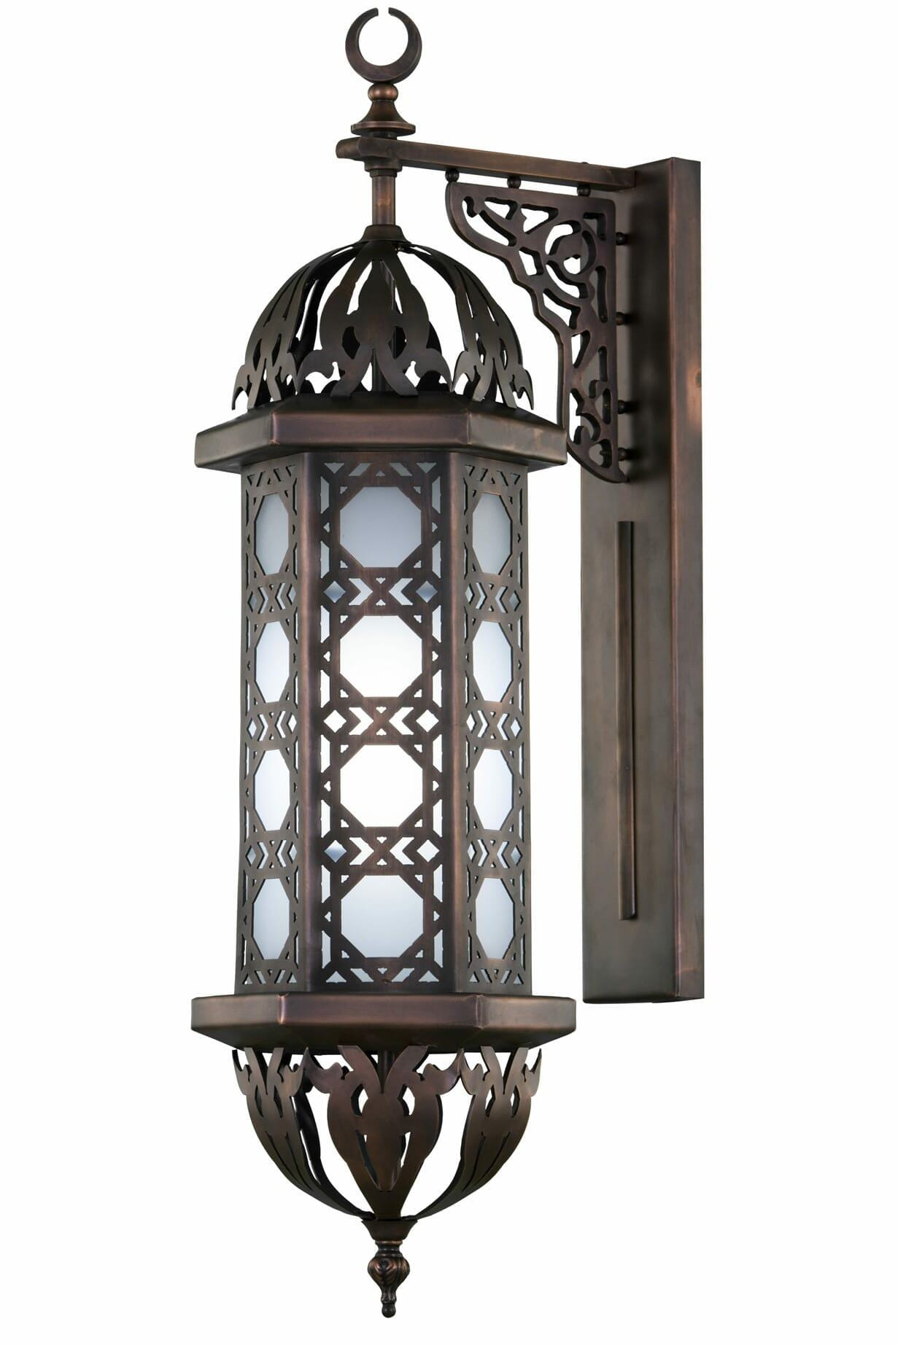

**Wall Bracket Old Brown Without Crystal - 1 Bulb**

Brand : AsfourProduct Type : Wall LampProduct Family : IslamicColor : Antique BrownMaterial : BrassDecoration Materials :...

Vendor: [Asfour Crystal](https://shop.asfourcrystal.com/collections/vendors?q=Asfour%20Crystal)

SKU: 34114/186/133/100

Availability: In Stock

Product Type: Wall Lamps

Subtotal: EGP 11,210.00

Bottom of Form

# Wall Bracket 16/1430/4 Gold Without Crystal - 4 BulbWall Bracket 16/1430/4 Gold Without Crystal - 4 Bulbs

5 sold in last 25 hours

- Brand : Asfour - Type : Wall Lamps - Color : Gold - Material : BrassNote...

Vendor: [Asfour Crystal](https://shop.asfourcrystal.com/collections/vendors?q=Asfour%20Crystal)

SKU: 34114/197/119/100

Availability: In Stock

Product Type: Wall Lamps

EGP 8,005.00

Please hurry! Only 4 left in stock

Brand :: Asfour Asfour

Top of Form

Bottom of Form

Top of Form

Subtotal: EGP 8,005.00

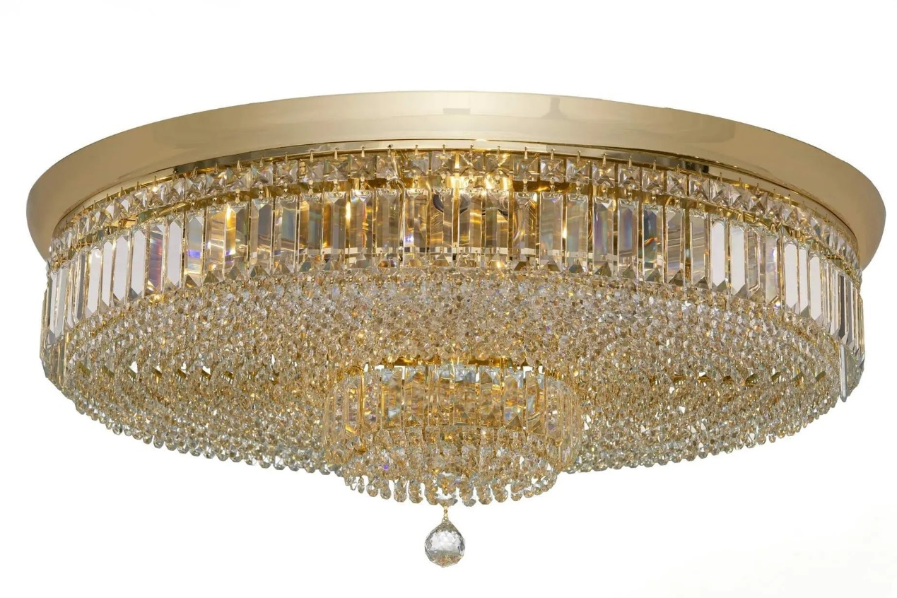

**Ceiling Lamp Gold Pendeloque - 13 Bulb**

Ceiling Lamp Gold Pendeloque - 13 Bulb About This Product Brand : AsfourProduct Type : PlafonnierProduct Family...

Vendor: [Asfour Crystal](https://shop.asfourcrystal.com/collections/vendors?q=Asfour%20Crystal)

SKU: 31513/299/119/131

Availability: In Stock

Product Type: Ceiling Lamps

Brand :: Asfour

Top of Form

Bottom of Form

Top of Form

Subtotal: EGP 26,553.00

Bottom of Form

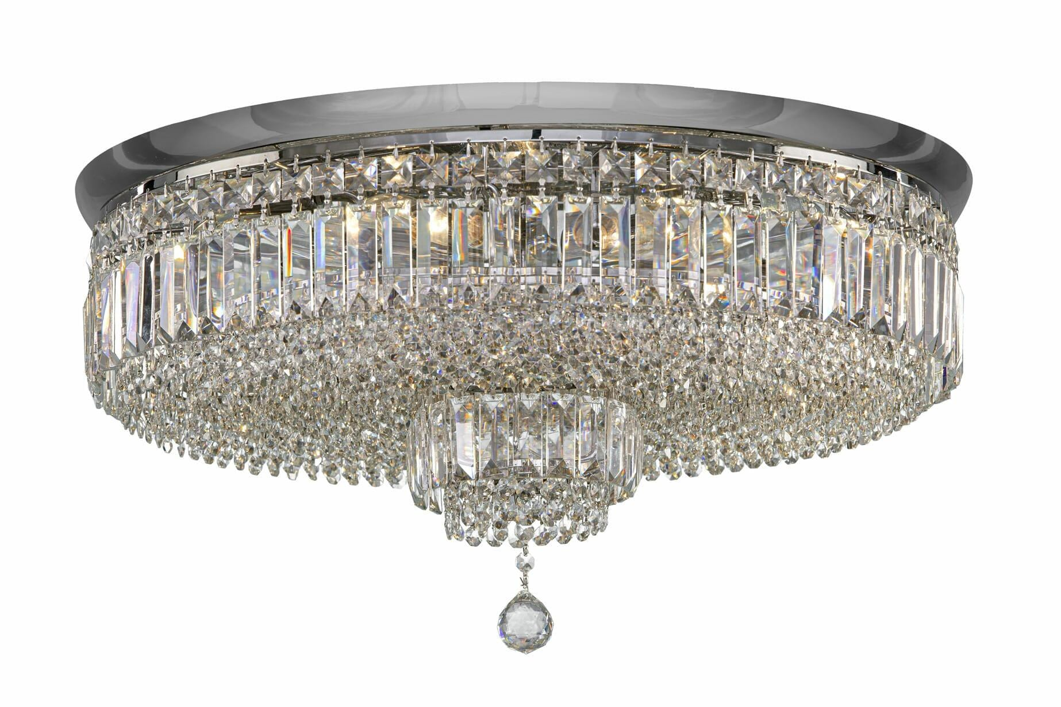

**Ceiling Lamp Chrome Pendeloque - 9 Bulb**

Ceiling Lamp Chrome Pendeloque - 9 Bulb About This Product Brand : AsfourProduct Type : PlafonnierProduct Family...

Vendor: [Asfour Crystal](https://shop.asfourcrystal.com/collections/vendors?q=Asfour%20Crystal)

SKU: 31513/298/121/131

Availability: In Stock

Product Type: Ceiling Lamps

Brand :: Asfour

Top of Form

Bottom of Form

Top of Form

Subtotal: EGP 17,313.00

Bottom of Form

# https://shop.asfourcrystal.com/cdn/shop/files/33114-877-119-154.jpg?v=1720013441Wall Bracket Gold

- Brand : Asfour- Type : Wall Lamps- Color : Gold- Material : BrassNote : Bulbs Not...

Vendor: [Asfour Crystal](https://shop.asfourcrystal.com/collections/vendors?q=Asfour%20Crystal)

SKU: 33114/877/119/154

Availability: In Stock

Product Type: Wall Lamps

Brand :: Asfour Asfour

Top of Form

Bottom of Form

Top of Form

Subtotal: EGP 5,550.00

Bottom of Form

Bottom of Form

Bottom of Form

Bottom of Form

Bottom of Form

Bottom of Form

Bottom of Form